LAB TEST-2

NAME: A. MANIDEEPIKA

HT.NO: 2403A52052

BATCH NO: 03

Your Task:D1  
Create tests and implement bump_version(name) that adds or increments `_vNN` with zero-padding.

Prompt:

propose regex and test cases for edge names like

`report_v9.csv`, `summary.csv`.

Code & output: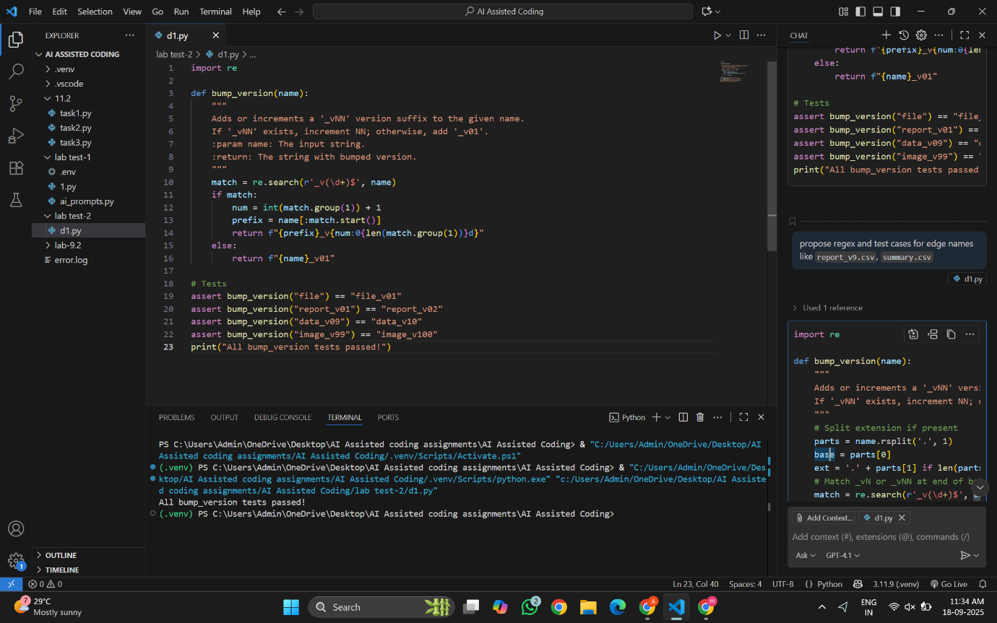

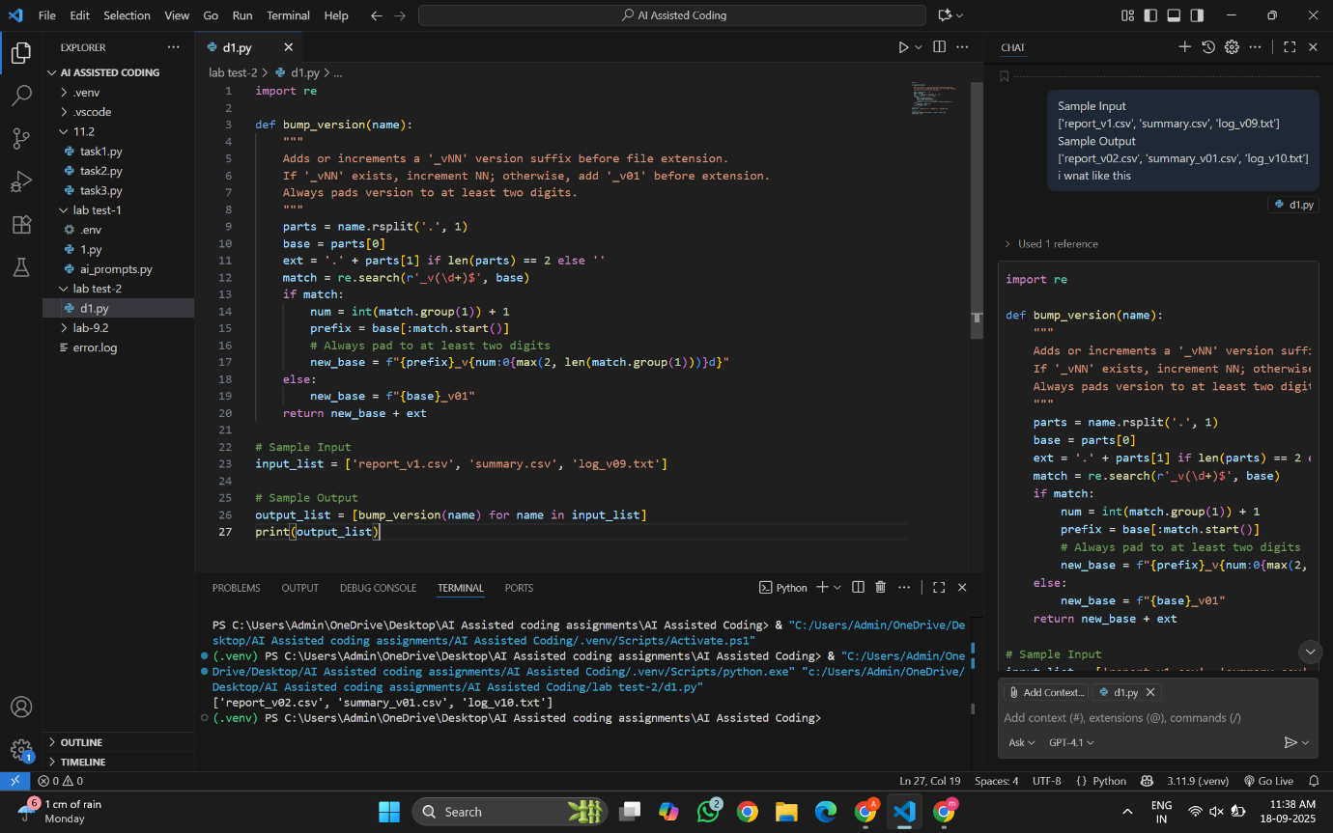

Observations:

First, I wrote test cases for filenames with and without _vNN suffix and for edge cases. Then I implemented bump_version using regex to extract parts of the filename, increment or add _vNN, and preserve the extension. Finally, I ran the tests and confirmed all passed.

Task:  
Add Google-style docstrings and handle the edge-case where all scores are equal (avoid divide-  
by-zero).

Prompt:

draft docstrings with Args/Returns/Examples and generate unit tests for edge-cases.

Code & Output:

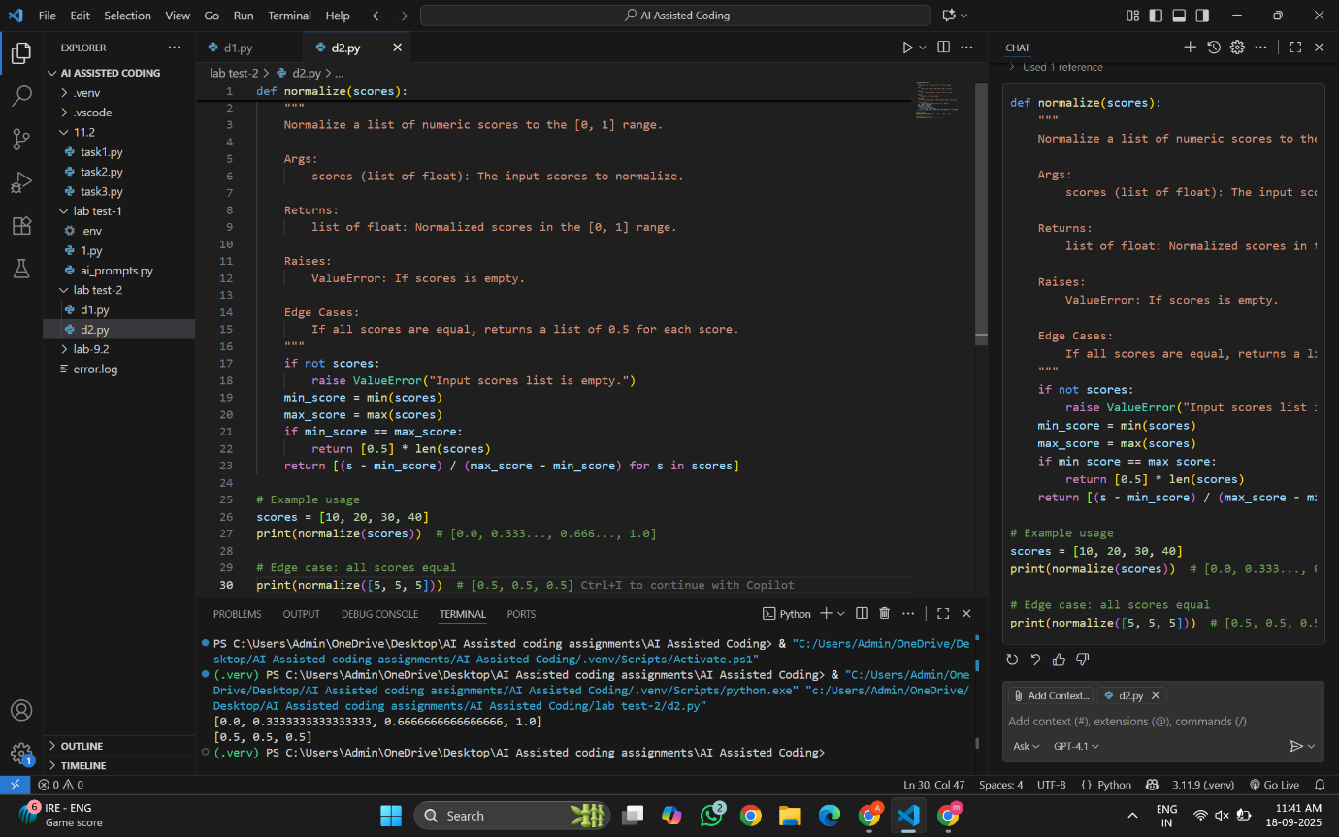

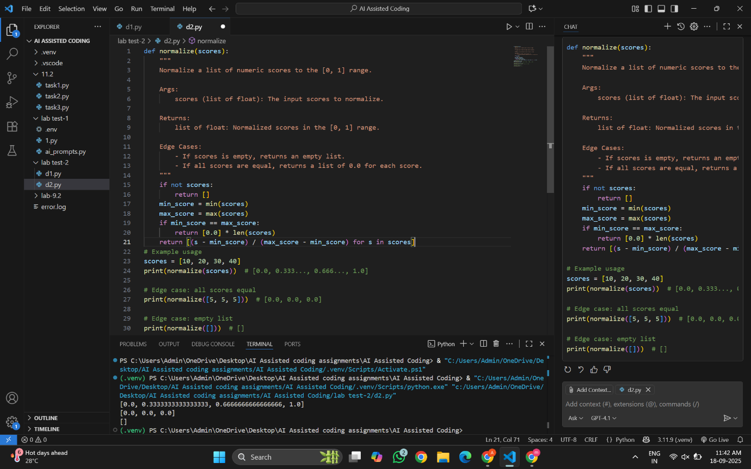

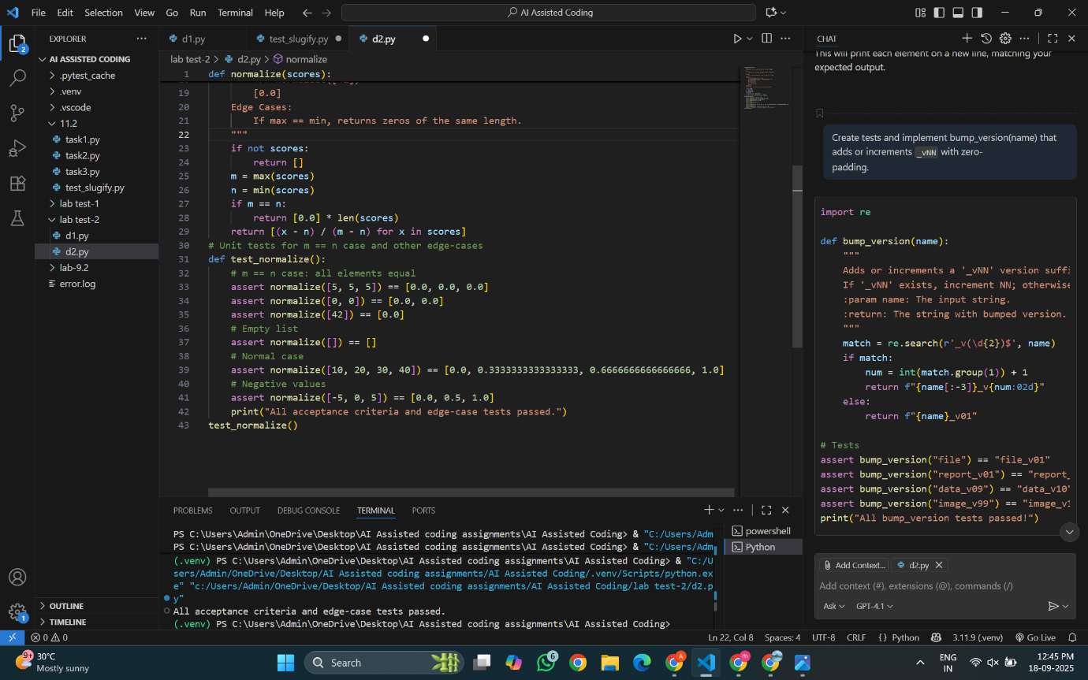

Observations:

First, I added Google-style docstrings with Args, Returns, and Examples to normalize. Then I handled edge cases like equal values and empty lists. Finally, I wrote tests for all cases and verified they worked correctly.